TSO – Tumor Study Organizer  
Pharmaceutical Oncology Project Database  
Application Development 1 Project Proposal

# Executive Summary

Cancer, the one true enemy to our human civilization. As humanity has progressed, we’ve dedicated billions of dollars into funding research to cure this accursed threat. And now, with the help of our little rodent friends, we can speed up the testing. The issue comes down to when we need to store data for said mice. As we all love the idea of doping a lot of mice at once, one problem comes to mind: “There are just too many mice!” Well, our software, TSO (Tumor Study Organizer), organizes information on mice dosing, mice groups, group information, mice information, and which pharmacologist is responsible for which mouse. This software will also feature tools to calculate mice volume/weight and tumor volume. Using this priceless piece of miracle software, we can help organize the pharmacologists’ information and calculate the volumes required for how much dosing a certain mouse needs. In turn, the pharmacologists can finally rest easy knowing that their research information is gathered into one, concise place.

# Project Background

As we are here to assist our cancer research comrades, we are building an outstanding application that implements a database to store all required information about the mice. The pharmacologists are working in oncology and are attempting to find a cure for cancer, so to help keep their data organized and to help calculate the required information to access the necessary data to conduct their research.

To accomplish such a grandiose mission, our tumor testing teammates need a database to organize the mice groups, the individual mice IDs, their weights, heights, and lengths, their dosing amounts, which doses to give them, and their tumor volumes. We will implement charts of data as well as user-friendly calculates that automatically save the calculations into the specific mouse’s data as necessary.

# Solutions and Approach

Our goal for this software is to help create a user-friendly software for these animal-tech pharmacologists to use to organize their research data. On top of that, our goal is to provide a helpful tool to calculate all their required measurements that can be immediately stored into the data of a specific mouse. To create this fantastic software, we will need a couple of features to ensure that it meets all the pharmacologists’ needs for their work.

We will deliver the following to give the pharmacologists an organized and unique software to meet all their needs. Firstly, we will obviously need to provide a “create mouse” button that can automatically ID the mouse. The pharmacologist can then organize it into their appropriate cage/group and input the appropriate dimensions and weight of the mouse.

Following creating the mouse, they can use a calculator feature to calculate the amount of dosing a certain mouse needs depending on its volume and which dose it is taking.

To differentiate between whether a mouse is actively being dosed/experimented on, there will be a section for “Active Studies.” With “Active Studies” comes “Previous Studies,” which will hold the information of previous mice that were tested so the pharmacologists can extract certain information from past studies.

On top of having “Active Studies,” the software can have a section of mice that are awaiting approval to be assessed, so “Pending Studies.”

To dose the mice, we obviously need an employee list of all the amazing pharmacologists who are putting in their best effort to find a way to beat cancer! This comes in handy for the calendar feature we’d like to apply and the employee assignment button for the mice.

When an employee opens the software, they will login under their specific credentials to access their employee profile to gather all their active studies and any private notes they may have.

To help keep the pharmacologists on track, we will implement a calendar feature that will label which employees will be on dosing duty from what time to what time.

The employee who is accessing the software will also have a feature to assign themselves to a group or to certain mice that they are dosing, which will be displayed in the mice information as well as on the calendar.

We will also include a feature that allows the pharmacologist to take notes for the specific study that they can store in a specific mouse’s information. They will also be able to take personal notes that will be stored in their employee account.

Lastly, to help the employee who is accessing the software at the moment find the studies with specific criteria, we will implement radio buttons to search for certain criteria, depending on which buttons are selected.

# Who will take ownership of the project

As mentioned prior, the main user of our application will be pharmacologists who specialize in oncology and who use mice to perform their studies. This will help them stay organized with their research, their notes, their mice, and their dosing’s.

# Additional Documents

This project proposal was inspired by Amanda’s brother, as he is currently a pharmacologist working in oncology. Oncology is the study and treatment of tumors. His team works on mice by injecting them with tumors and then testing different types of medicine on them to see how it affects them.

Their team uses an application called “StudyLog”. Most of the ideas for our software were inspired by this application. A demonstration of the application can be found using the following YouTube link: <youtube.com/watch?v=2i4vOs1SbDo>.

Here is an example of what the group page information looks like (courtesy of Amanda’s brother):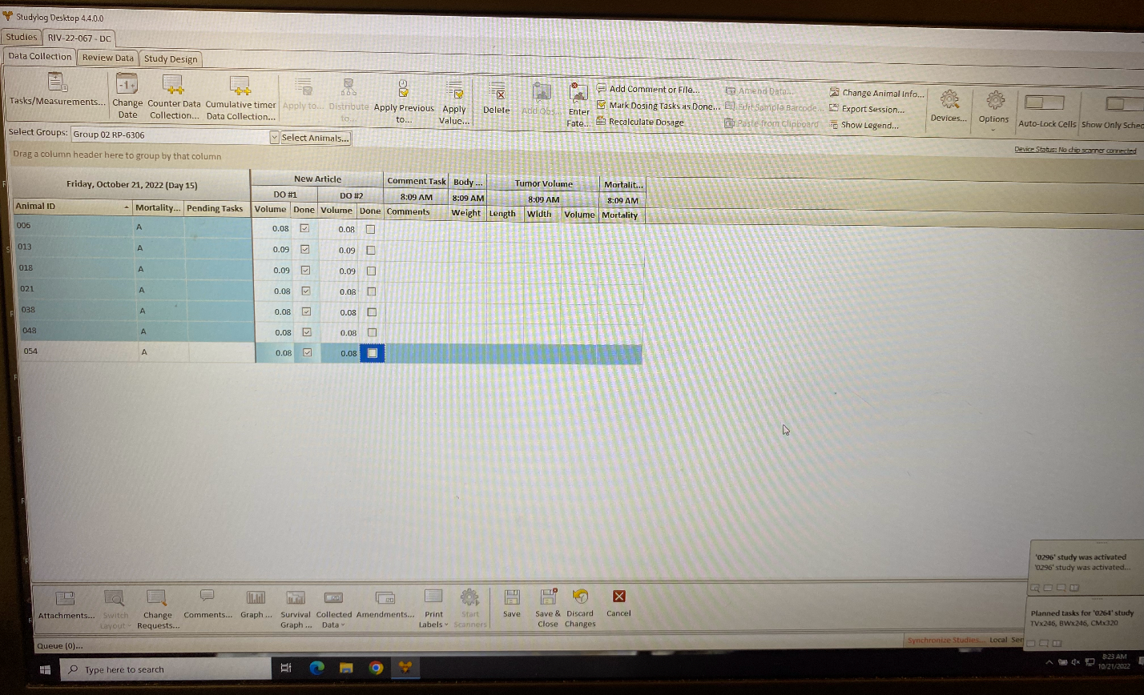

To make the software as accurate and useful as possible, we will ask Amanda’s brother for specifics on certain features of the application and what will be necessary to make this software useful for pharmacologists that are handling mice for oncology.

# Team Members

Amanda De Rosa (2070441) – (420-331-VA sect.00002)

James Kawashima (2148113) – (420-331-VA sect.00001)